Brochure title
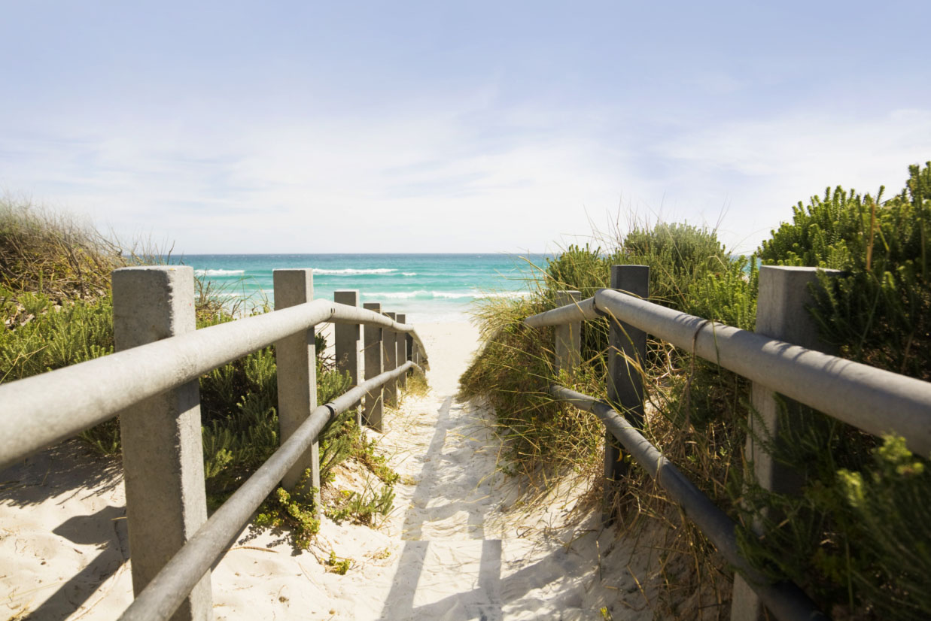

Promote a great offer here!
It’s easy to make this brochure your own. To replace placeholder text with your own, just select it and then start typing. Don’t include space to the right or left of the characters in your selection. | Price

Get the picture  To replace a photo with your own, just delete it and then, on the Insert tab, click Picture. |  | Make it a photo finish  Start with like-sized images for best results in this layout. Then right-click a photo for easy Grow and Shrink options. |  | Show off your style  Select a photo and then, on the Picture Tools Format tab, apply a picture style or scale photos to a specific size.

Company Name
Add your tagline or other closing text here | email address | web address | telephone

